**Telecom Dataset Project (SQL)**

1. **Total Revenue**

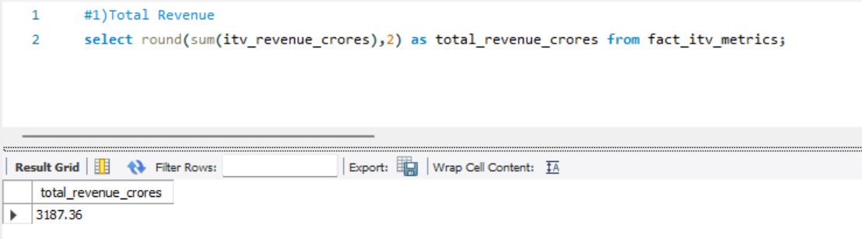

1. **Avg Revenue**

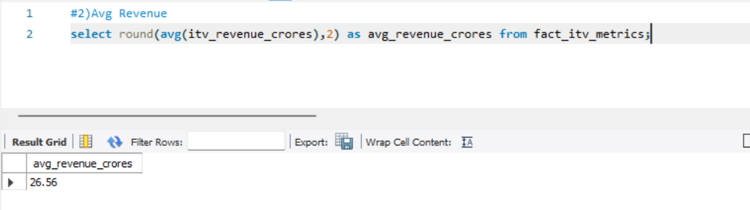

1. **Average Revenue Per User**

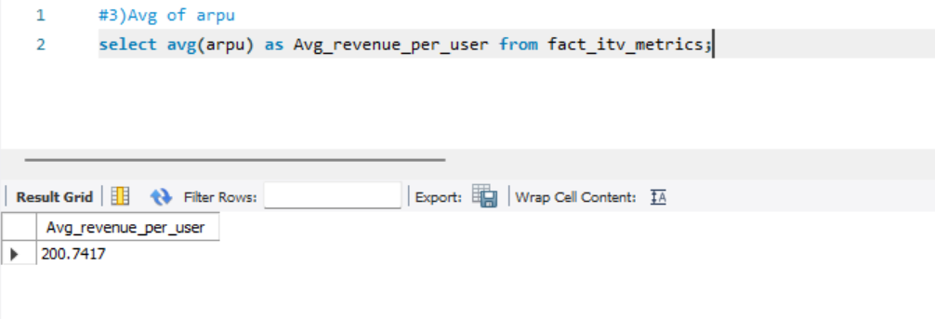

1. **Total Active Users**

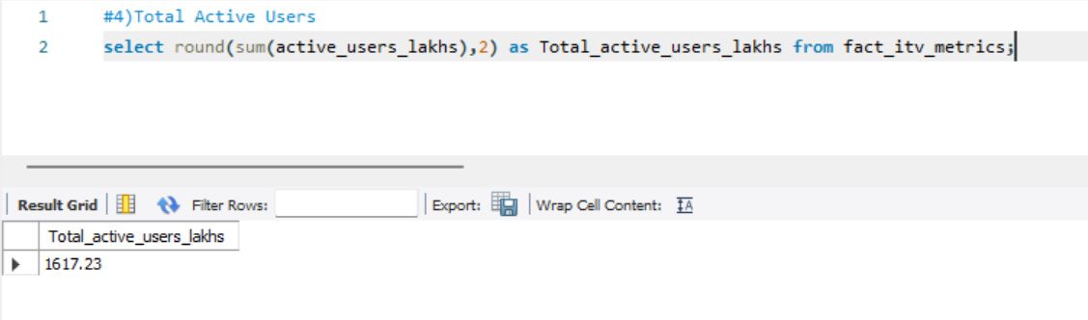

1. **Total Unsubscribed Users**

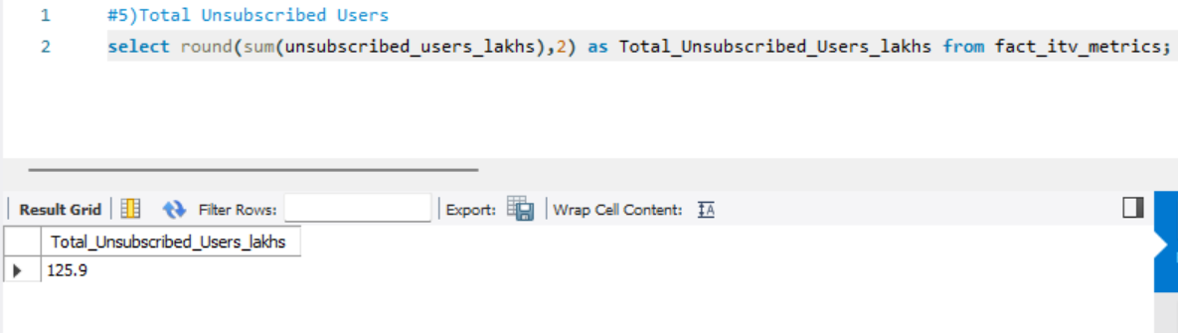

**6) Monthly active users**

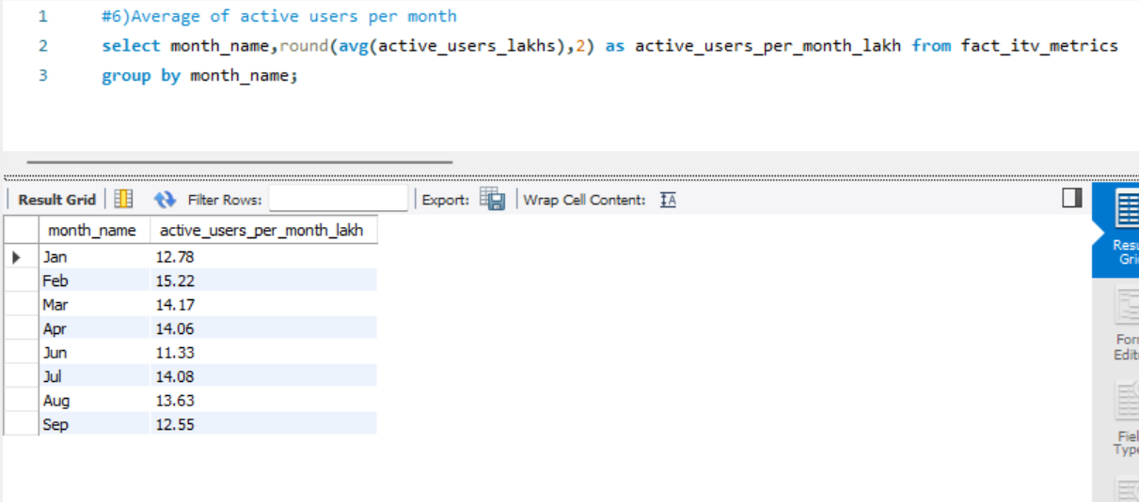

1. **Market Share %**

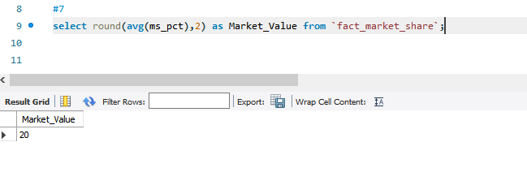

1. **Revenue Before 5G**

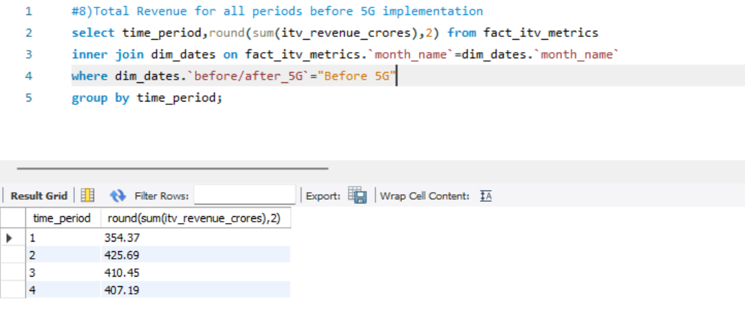

1. **Revenue After 5G**

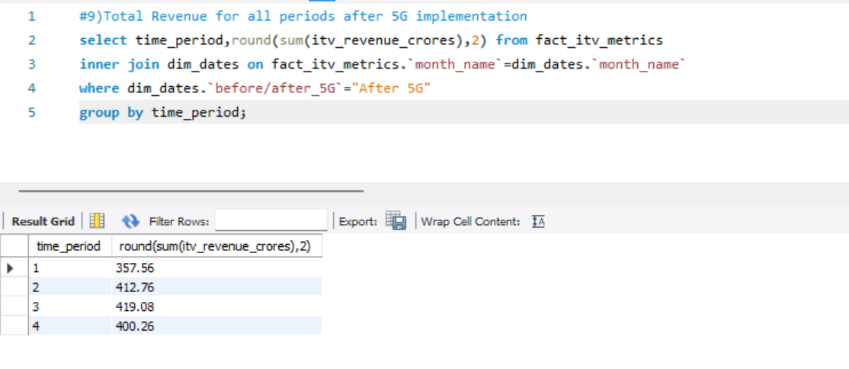

1. **ARPU Before 5G**

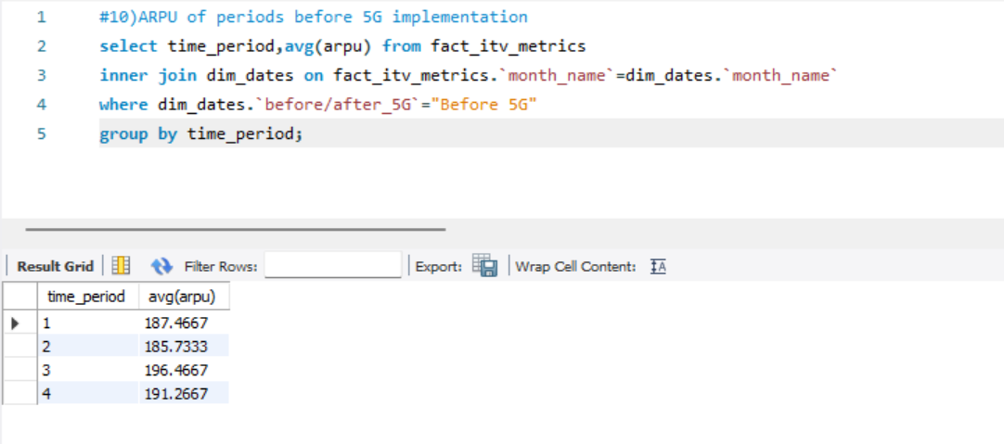

1. **ARPU After 5G**

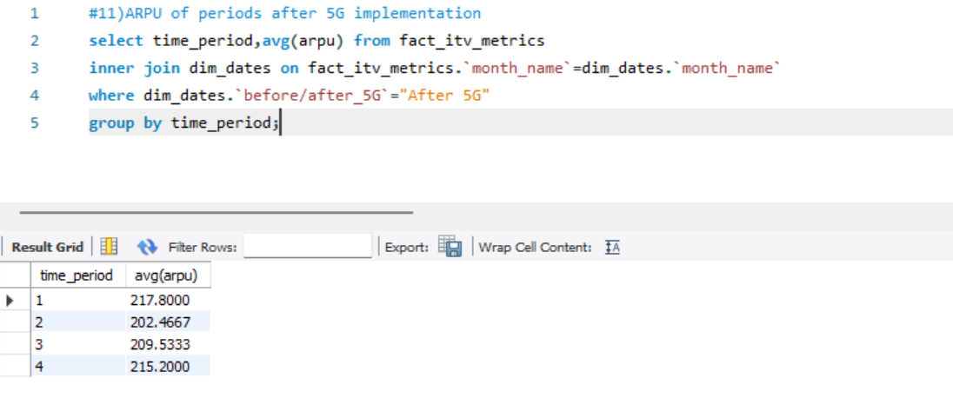

1. **Active Users Before 5G**

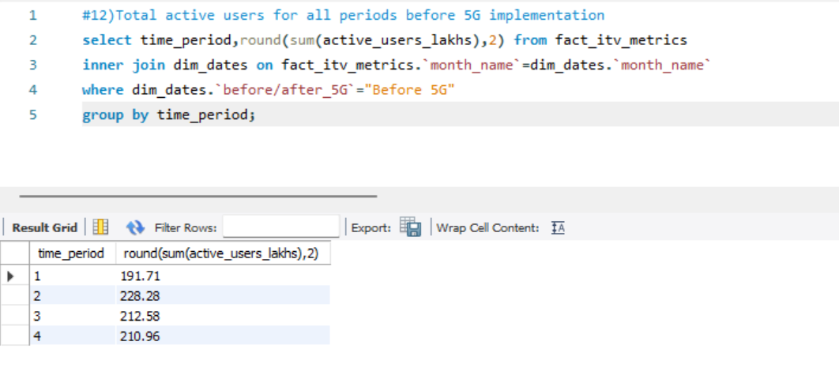

1. **Active Users After 5G**

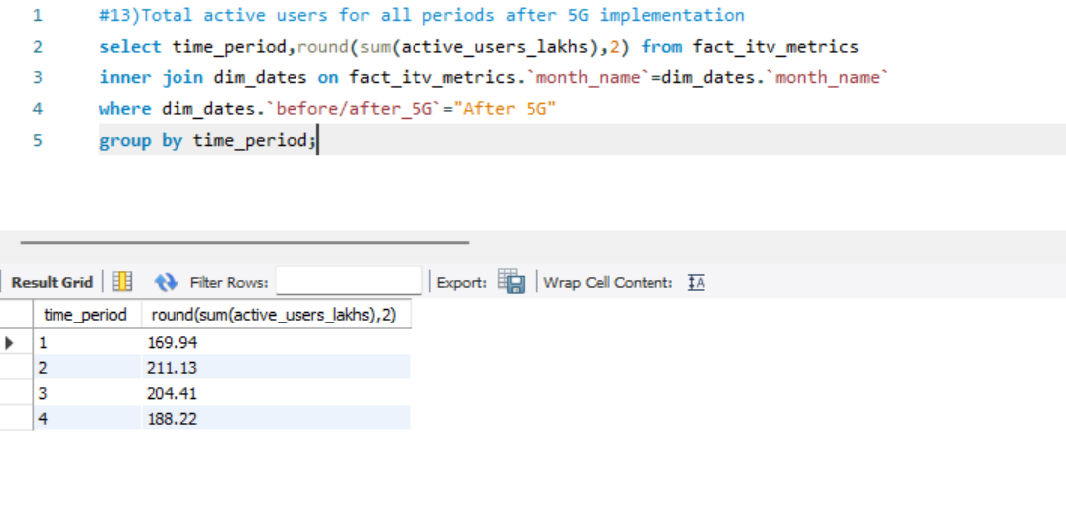

1. **Unsubscribed users Before 5G**

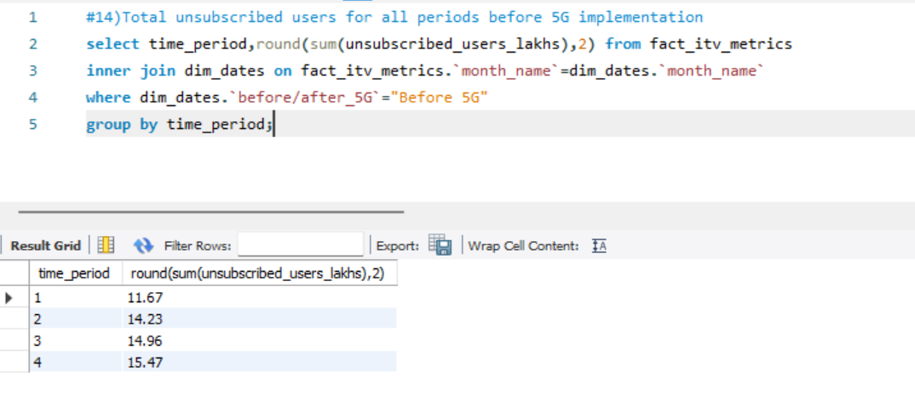

1. **Unsubscribed users After 5G**

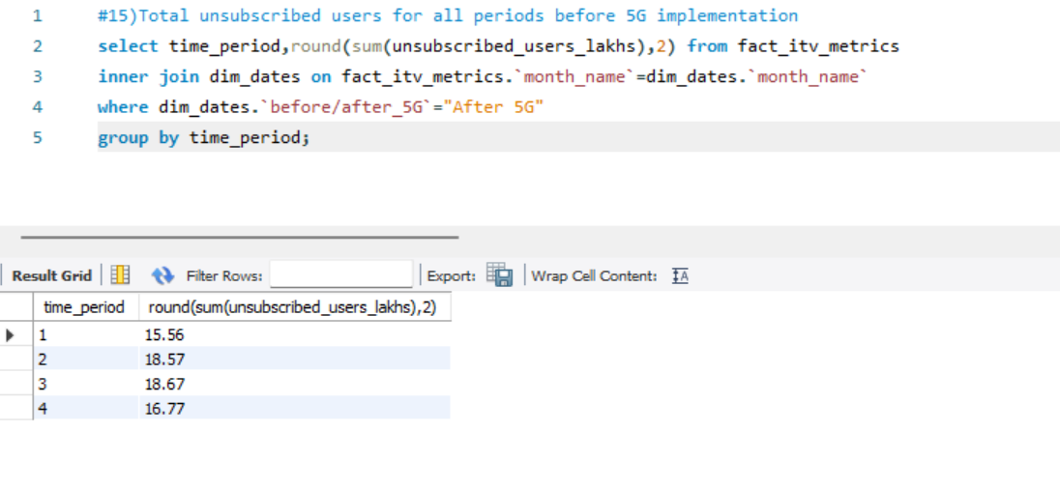

1. **Percentage growth in revenue before and after 5g implementation for each city**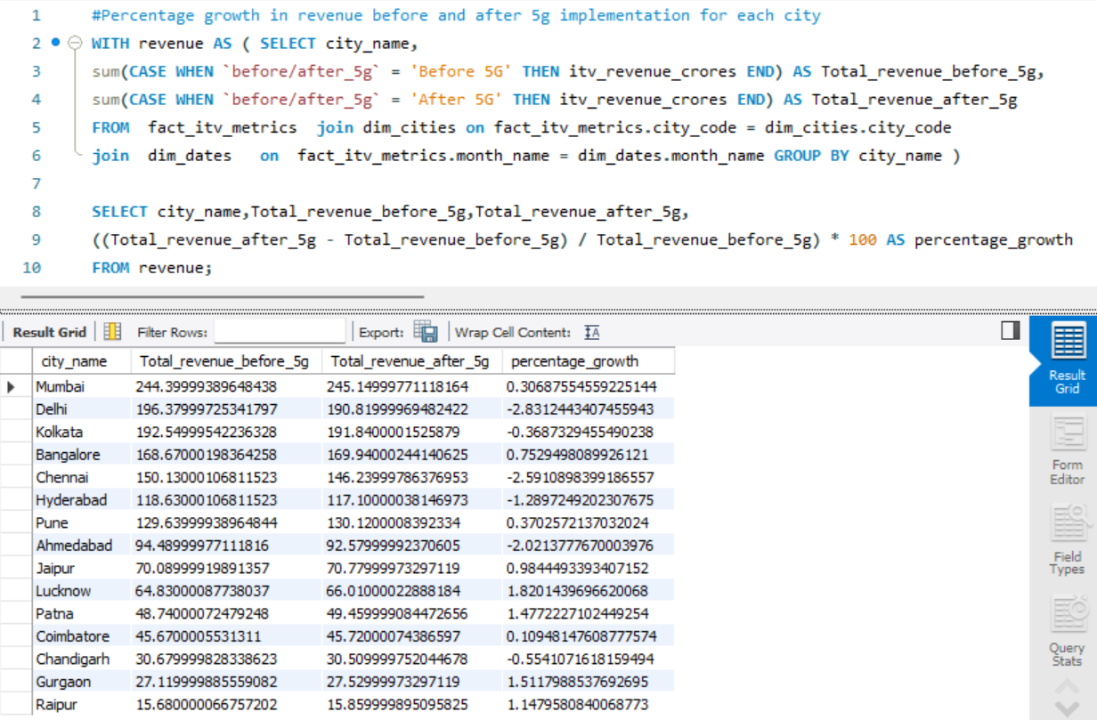
2. **Percentage growth in revenue before and after 5g implementation for each plan**

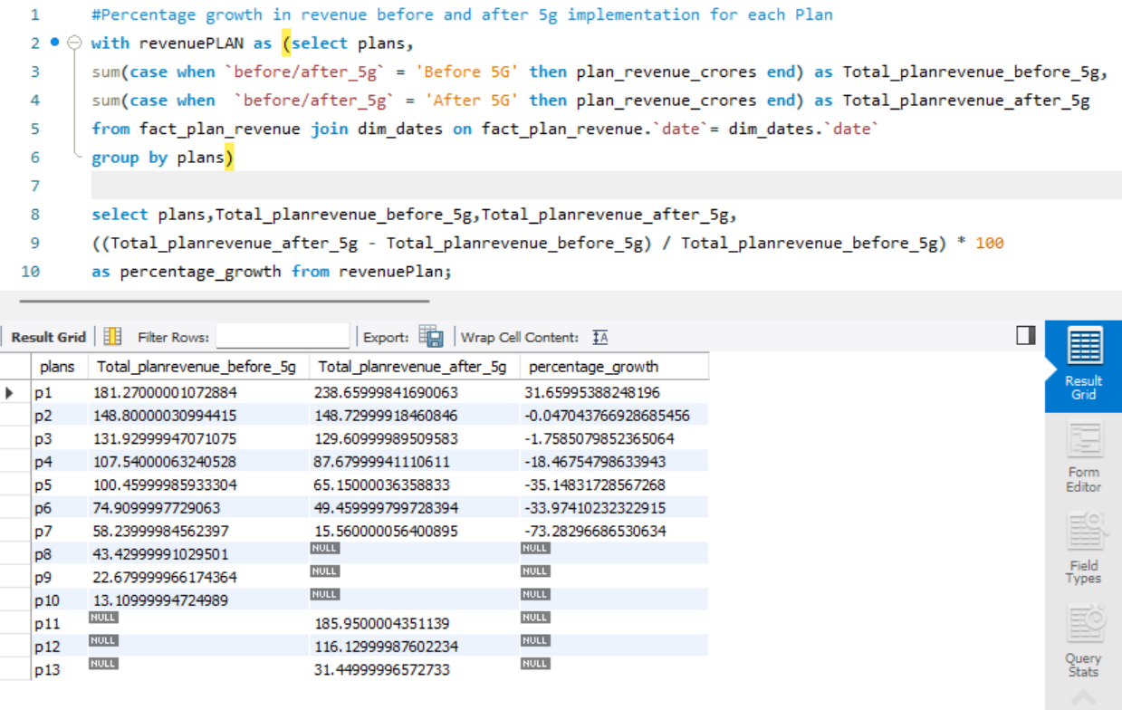

1. **City wise active users in lakh before 5g and after 5g**

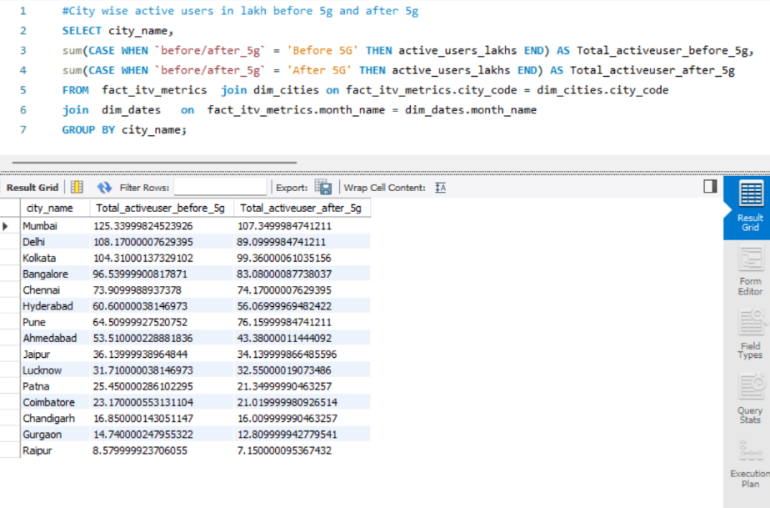

1. **Market share over months for all companies**

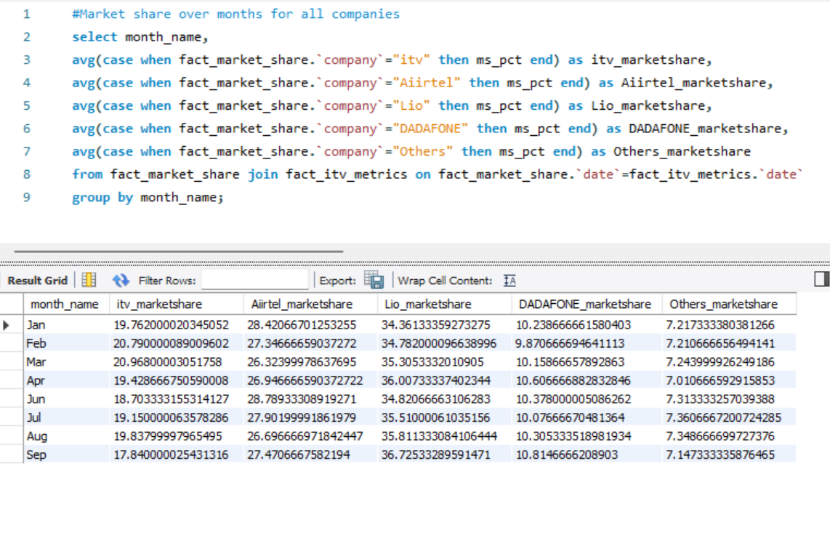

1. **Top Plans by revenue**

1. **Monthly trend of avg ARPU before and after 5g**

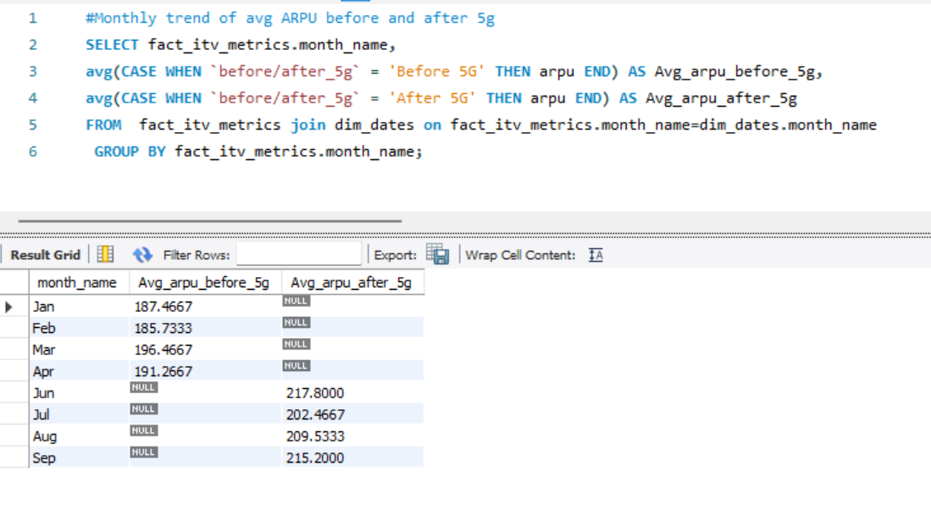

1. **Monthly trend of avg active users before and after 5g**

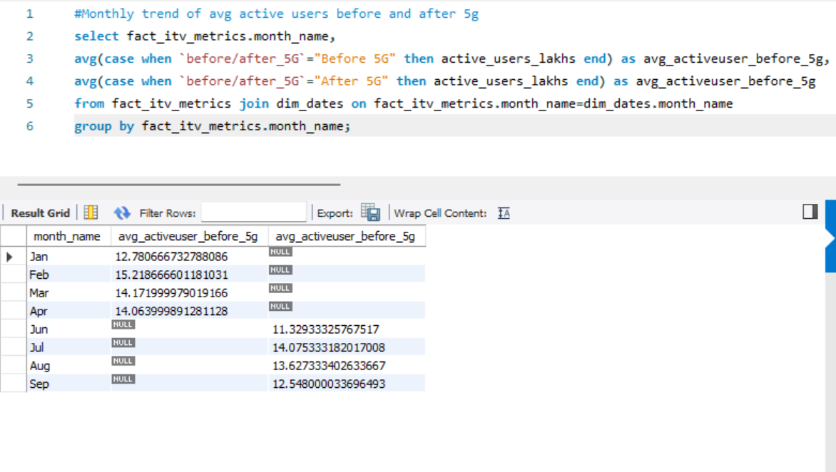

1. **Monthly trend of unsubscribed users before 5g and after 5g**

